**Measure Phase for Automated Palm Pruner**

Fall 2011 – December 6, 2011

Submitted By:

Obie Abakporo

Bill Carpenter

William Craig

Juan Antonio Rojas

Christopher Xavier Smith

Sarah Trayner

*Dr. Okenwa Okoli*

*Industrial and Manufacturing Engineering Department*

*FAMU – FSU College of Engineering*

Table of Contents

Introduction 3

Progression of Define Phase to Measure Phase 4

Tool Selection 6

Engineering Analysis of Concept Designs 11

Concept 1: King Climber 12

Concept 2: Rolling Thunder 25

Evaluation of Results 32

Conclusion 34

Appendix 35

# Introduction

The goal of our project is to develop a computer-integrated robot that will be able to climb a 60 ft oil palm and harvest the palms efficiently and economically. For this process, we are utilizing DMADV, also known as Define, Measure, Analyze, Design, and Verify, in order to develop a new product. We are on phase 2 of this process, known as measure. Previously, in the define phase, we were able to clarify the purpose and scope of our project as well as the understanding of the process to be improved, and the customer’s expectations for quality. Our main purpose is to create a new device for an oil palm harvester that will minimize the amount of work completed by the worker, as well as, improve the overall process safety. The define phase allowed us to have a thorough understanding of previous techniques for harvesting oil palm fruits as well as the customer expectations that we have to take into consideration in order to create a successful machine.

The tools that proved most useful were the Fishbone Diagram, the Voice of Customer Tree, as well as the House of Quality. These can be found in the Appendix. The Fishbone Diagram, also known as a cause and effect diagram enabled us to identify the problem, understand the factors, identify possible causes, and analyze the end result. Overall, this technique of brainstorming increased our knowledge on factors that we should focus closely on when creating possible design concepts, as well as, allow for a better grasp on our problem. Another useful tool was the Voice of the Customer Tree. The Voice of the Customer Tree allowed us to capture the customer’s voice through stated and unstated customer needs and requirements. This is important because our main goal is to satisfy the customer by addressing and implementing all of their needs. Finally, the last tool that we utilized in the define phase was the House of Quality. This tool proved most crucial because it allowed us to define the relationship between the customer’s desires and our own capabilities. Through these tools, we obtained our main constraints: weight, the force required, power, velocity, time, material, and cost.

# Progression of Define Phase to Measure Phase

The tools utilized in the define phase set the foundation for the measure phase. In the define phase, the major tool that allowed us to figure out what we are going to measure was the House of Quality depicted in Figure 1. The House of Quality gives technical weights to each requirement showing the importance of each factor. From this, we decided to concentrate on the efficiency of the machine, the weight of the robot, as well as the costs associated with each design concept concerning materials and production. For the efficiency aspect, we are including variables such as time, power, and the overall force required to climb the tree. These requirements, shown highlighted in Figure 1, scored relatively high in our correlation matrix and will be the main focus of in our measure phase.

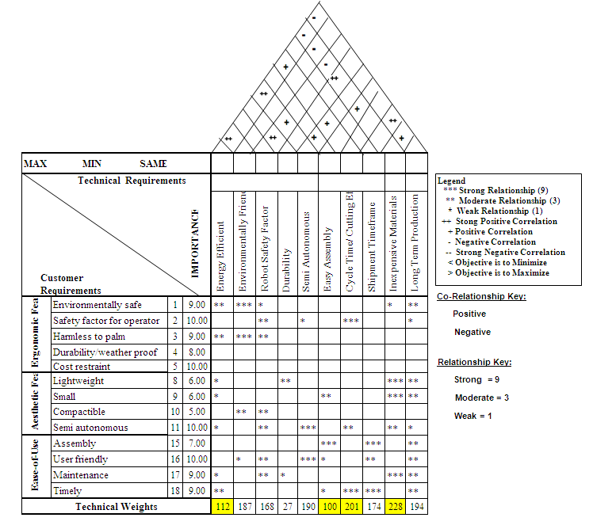

Figure 1: House of Quality

For the selection process, we measured and compared parameters for both concept designs. Each

parameter is crucial for varied reasons. Weight is important because it plays a key role in calculating the force and velocity of the robots, respectively. In the end, we want to choose the quicker robot design that can climb the palm tree in a timely and efficient manner. Not only does the weight of the robot affect force and velocity, it also determines the manpower required to move the robot from tree to tree. The next major parameter is the material. The chosen aluminum material for each robot will play a significant factor in the overall weight of the machine due to the density of aluminum. In addition to weight, the material directly affects the total cost of each robot and is a key component due to our given budget of $2000. The cost will be based on the prices from various companies considering the desired materials. Using the information that we calculated; the power, velocity and time for each design can easily be found. After the time was calculated, we were able to figure out the productivity of each robot.

# Tool Selection

After utilizing the tools and charts in our define phase, we realized that our measure phase would need to show a comparison between both concept designs, Rolling Thunder and King Climber. This would allow us to choose the best possible concept design in order to achieve our goal in creating an optimal product. The tools we utilized in our measure phase include a Venn diagram, a Pugh Selection Matrix, as well as a Traditional Selection Matrix. These tools would help us determine which robot would be most successful.

Figure 2a portrays a Venn diagram. This allows us to visualize between both design concepts so that we can see both similarities and differences between both ideas, which will ultimately lead to the more optimal design selection. The differences in the two concepts will be the deciding factors, because the similarities essentially cancel each other out.

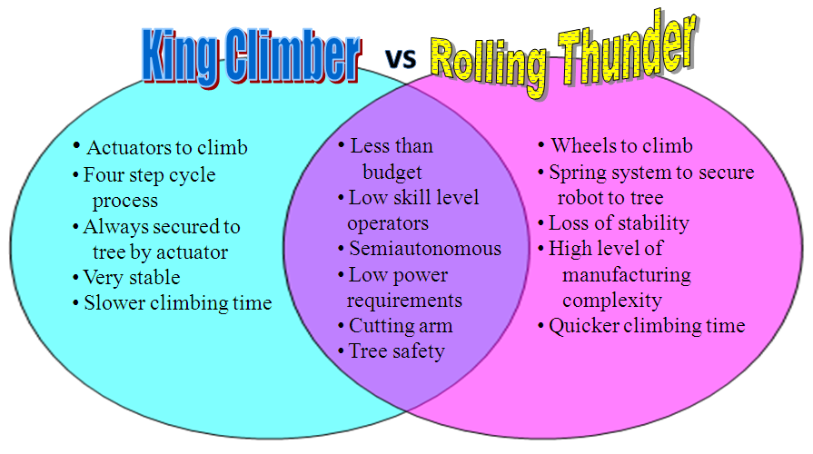

**Figure 2: Venn Diagram**

Below, Figure 2b portrays a Pugh Selection Matrix. This is very helpful in the selection process because it is designed to evaluate multiple options against each other, relative to a baseline option. It is more commonly known as a selection or decision matrix for this reason. The goal of the Pugh Selection Matrix is to maximize the major parameters while the goal of the other selection matrix will be to minimize the other major parameters. However, this method does have a flaw in that we cannot account for qualitative factors. On the other hand, we will be able to assess distinct factors such as: complexity, stability, and mobility. As a result, we can compare the concepts on a general basis, and not just the numerical values, which could be irrelevant if the overall design is flawed.

**Table 1: Pugh Selection Matrix**

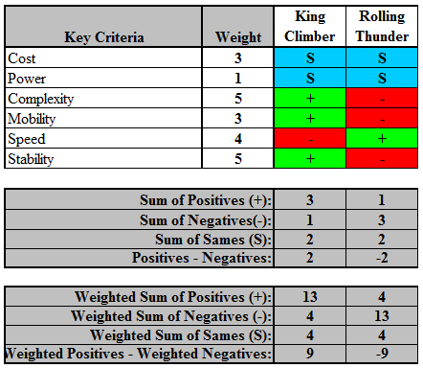

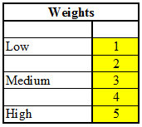 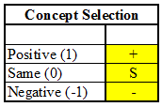

**Matrix Keys:**

Based on the sum values, we will be able to determine which design will be the better choice. First we must add up all the positive, same, and negative signs per column. After we get a numerical value based on the concept selection key, we must multiply those values by the weights that we assigned to each of the respective criteria. Once we do this step, we can compare the concepts with a more relative scale.

We assigned weights based on relative importance. Since designing a working robot is the main concern, we placed the most weight on the complexity and stability of the designs. Then, we decided, assuming that the robot would work, that speed has a high level of importance as well. This is because it is directly related to productivity. This is important to us because if a customer purchases a product, then the product is expected to produce optimal results. Next, the two important factors are cost and mobility. Mobility is considered to be the process of moving the robot from tree to tree. The reason King Climber received a better rating is the fact that it is much easier to carry from tree to tree. Although the Rolling Thunder has wheels, those wheels are not intended for transportation of the robot. This leaves the Rolling Thunder as a very cumbersome object, which places mobility in favor of the King Climber. The cost would have had a higher value considering we are under a budget restriction, but both of the designs were under our allotted budget. Not only were they both under our given budget, they were also very similar, which is another reason that the importance was reduced. After the calculations, our power was the least of our concerns because both designs had low level power requirements. With the power calculations being minimal and similar, we could choose the same generator for both robots.

The weighted values for the King Climber and Rolling Thunder are 9 and -9, respectively. Since 9 is the largest value, the King Climber proves to be a more appropriate choice. This decision, based on the Pugh Selection Matrix, considers the relevant factors and the importance of each one. When comparing our two concept designs, we have a value of 9 and -9. The biggest reasons for the difference in values are the stability and complexity of the designs. When we take into consideration the concept design for Rolling Thunder, we see that it is extremely complex and may not be able to be assembled in the allotted time. Another obstacle of the Rolling Thunder is figuring out how the robot will be able to secure itself to the tree. We realized that this design is not conducive to the cutting process because it uses a system of wheels that are kept on the tree by a spring force. Basically, the results obtained from this selection tool reveal that the stability of the robot is compromised by the force of the cutter and the movement required to prune the oil palm.

The final tool we used in our measure phase was a Traditional Selection Matrix seen in Figure 2c. A Traditional Selection Matrix takes into account the different metrics that we used to define our two concepts. The different metrics helped us compare the different quantitative values. The goal of the selection matrix is to calculate a weighted value and choose the lowest sum of the calculations.

The first step was to calculate all of the metrics for the two given concepts. Next, we assigned weighted values to our different metrics. After this was completed, we had to calculate the ratio of the concept designs. In order to complete this, we took the values for the metrics and the respective designs and divided the respective metric by the lowest value in the row for the design. This creates more manageable numbers and results in a more precise value concerning metrics so that we can efficiently compare the two designs.

Once we calculated the ratios, we multiplied the respective ratios by the designated values in the weight column. This gave us the weighted concept design values. The values in the weighted concept designs columns are then cumulatively added and compared. Based on the values in our selection matrix, the Rolling Thunder produced the better value. With the respective totals, we cannot positively identify the optimal solution. But this tool does help us get a better understanding of our two designs. The only downside to this table is the fact that we could not include values for metrics such as: speed, complexity, or mobility. The reasoning behind this is that this particular selection matrix is based on finding the lowest value. If we were to include speed, it would give us an inaccurate reading because, in actuality, we would prefer the robot that has the fastest speed. If we were to include speed and give it the appropriate weight rating, it would favor the slower robot.

**Table 2: Traditional Selection Matrix**

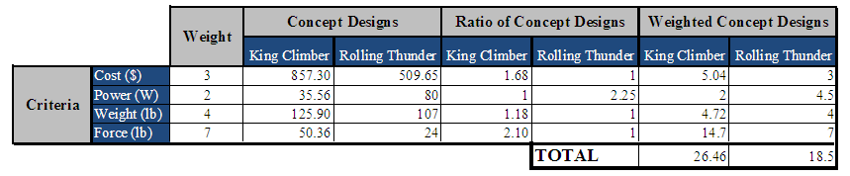

As a result, we implemented these quantitative ways to prove which concept design, either Rolling Thunder or King Climber, was the most promising when it comes to investing our time and effort.

Ultimately, we must please the customer and create an efficient working prototype. Therefore, the measurements between the two concepts are the primary focus of this phase. Along with the quantitative tools we utilized, we must also take into consideration the overall design of the concepts. Although one design could be superior in speed, it may be irrelevant due to the design flaws. Just because a robot can quickly climb to the top of the palm tree, does not mean that robot is the best choice. If the robot cannot perform the task of cutting the fruit down, then the quick climbing is pointless.

## Engineering Analysis of Concept Designs

Engineering analysis was utilized to calculate and evaluate both concept designs. Both sections portray the thinking process our team utilized in order to calculate the necessary numeric values needed to justify our final decision. Both sections will focus on providing results to the following:

1. Generate an estimated total weight of the climber including a cutter payload
2. Using our physics and engineering classes, calculate:
   1. the amount of force need to keep the climber on the tree
   2. the amount of power needed to make the robot climb
   3. the speed at which it can climb
3. Check the compatibility of the materials and make sure

that they can handle the forces

1. Select hypothetical parts and components, calculate rough cost estimate based on

prices given by various companies for specific parts

## Concept 1: King Climber

The King Climber design was one of our major concepts that made it to the analysis phase. The Pro-Engineer model below is broken into five main components depicted in Figure 3. The first component consists of the track for the manipulator arm and is located at the top having a separate frame. Next, four guiding rods are secured to each corner of the lower frame in order to keep the top and bottom frames aligned. Another major component is the upper frame. The upper frame guides the device up the palm tree. Moving downwards, vertical actuators are placed on the adjacent side of the hinges along the center line of the frame. This allows the entire device to be lifted upwards. Finally, the last major component consists of multiple thick horizontal rods that are placed into the square frame. They are placed into the square frame utilizing grappling plates attached to the horizontal actuators and are the mechanism that provides the required force to keep the device attached to the tree.

**Figure 3: Pro-E Model for King Climber**

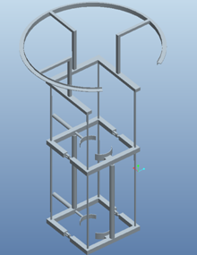

The Pro-E simulation of King Climber illustrates a computer generated prototype of the design. This allows us to visualize what is happening in the design as well as obtain a practical representation of the anticipated applied loads and stresses experienced. By utilizing the Pro-E software, we can easily show the various degrees of stresses applied to the design at various points via contour plot. Even though all actions in the concept design cannot be accounted for in a laboratory or experimental setting, creating Pro-E simulations are the best technique in order to evaluate and measure the potential concept design. This technique allows the user to grasp a full understanding of how King Climber works. In addition to providing graphical representations of data, we also utilized Pro-E to generate animations to display the functionality of our design. This way, we can convey the capabilities of our product verbally, visually, and virtually to our customers without requiring them to actually engage in physical contact with the machine.

Each component of the King Climber has its own corresponding contour plot that shows the maximum stress points experienced from the load imposed on the machine at these points. These aid in the engineering analysis and distinguish between which area needs to be strengthened. Also, it allows us to verify that the material chosen can withstand the expected stresses. For example, on Figure 4a, the largest load is experienced at the bottom corners of the tree grappling clamps. This is indicated by the red color on the contour plot. This section was anticipated to have the largest stress because it shows the points where the majority of the force will be put on the machine in order to safely secure it to the tree. Ideally, the load will be evenly distributed along the grappler but, due to the geometry of the tree grappler that was not feasible.

Figure 4a: Finite Element Analysis on the lower actuator frame.

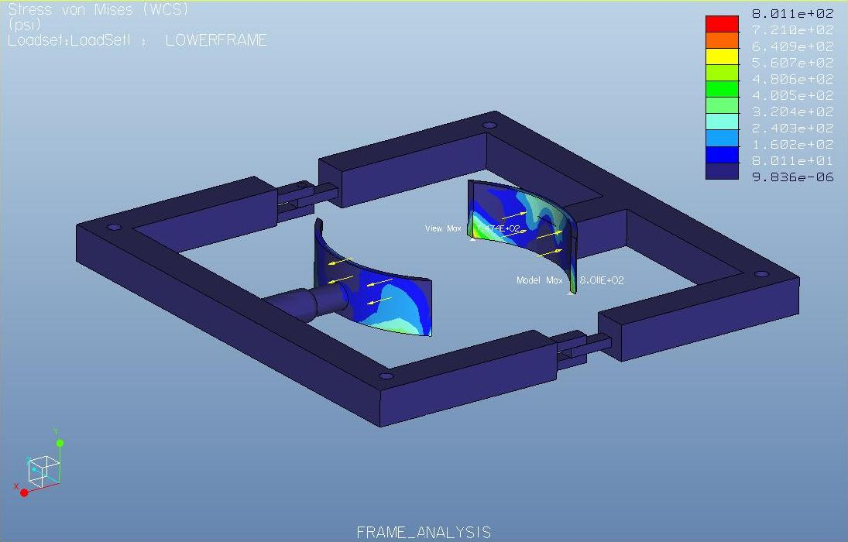

In Figure 4b, four guiding rods are implemented in the lower frame. This image portrays the stresses in the vertical actuators as well as the guiding rods. All four guiding rods show uniform loading on the vertical support rods. These results show that these stresses fall within the acceptable range for the material selection.

Figure 4b: Finite Element Analysis of Lower Frame

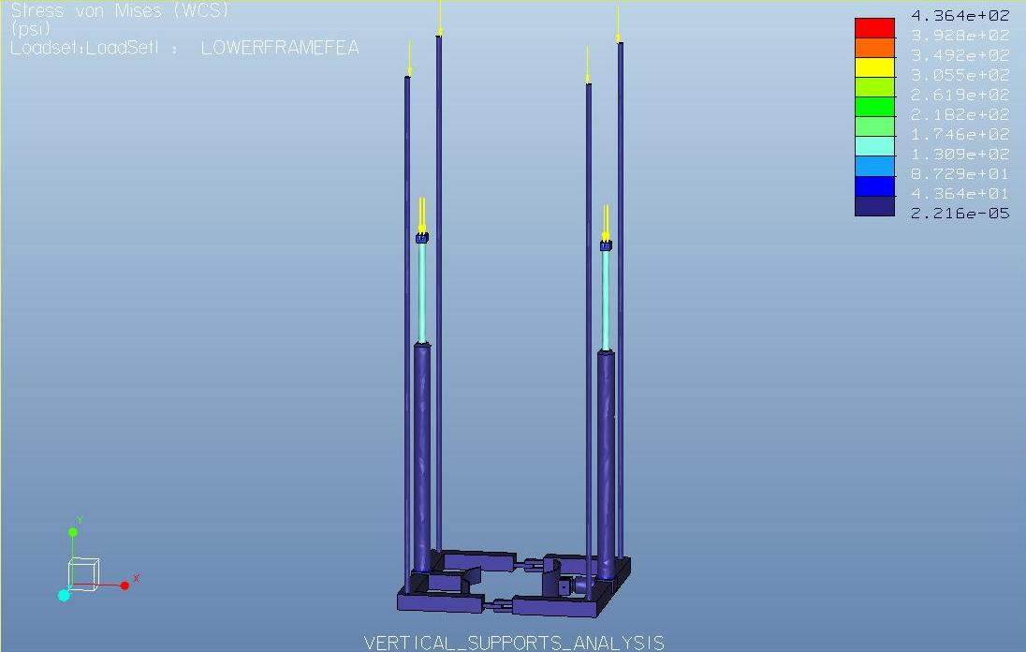

In Figure 4c, finite element analysis was used to analyze the manipulator track having a

payload of 50 lbs. The arrow depicts where the point load is applied. This image shows that there is a

high stress concentration near the welds between the frame support and the circular track, as well as

locally near the point where the load is applied.

Figure 4c: Finite Element Analysis on the manipulator track

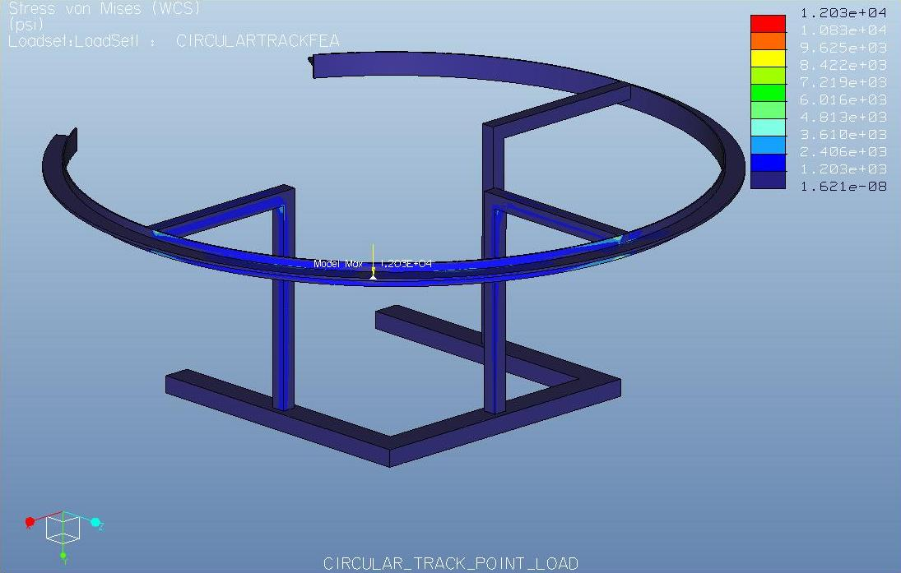

**Results of Analysis of Design:**

**#1: Testing Geometry and Calculating Weight**

Geometric Calculations:

The first step in our calculations is to determine the amount of material used. To do this, we must first calculate the dimensions of our robot. Assuming a diameter of 14 inches for the tree, we decided that the robot would only climb trees ranging from 8-17 inches in diameter. So we will essentially be working with a 26” x 26” square frame for the top and bottom horizontal actuator. Also, we must take into account the frame itself.

$P=2l+2w$ (1.1)

$$P=2\left(26"\right)+ 2\left(26"\right)=104"$$

$l$ 26” $w$ 
  
  
  
  
  
 26”

We have selected Aluminum 6061 2” x 2” square tubing for the frame, given its mechanical properties and weldability. Since our design requires both an upper and lower frame, we must multiply this number (104”) by 2.

After the amount of material needed for the frame is found, we have to calculate the amount of material needed to produce the track that the cutter will move around on. Since we need to cut all around the top of the tree, we will place a cutting track above the top frame which will allow the cutting arm to rotate 270° around the tree. We will not be able to emcompass the entire tree with the cutting track, so there will be an opening on the front end of the robot. We will use 6 straight tubes as the supports for the circular track and a single T-beam as the track itself. Each support tube will be 16 inches long and the track will be 129.59 inches long.

$Aluminum track Circumference=\frac{270}{360} \left(2π* r\right)=129.59 in$ (1.2)

Weight Calculations:

Total weight

The first step in figuring out the weight of the robot will be determining the total amount of raw material we will use. We must consider the material that it takes to build the upper and lower frame, along with the cutting track. This is summarized in Figure 5a.

**Figure 5a: Material Lengths Required**

|  |  |
| --- | --- |
| **Raw Material Lengths (Al6061)** | **Inches** |
| Upper | 104 |
| Lower | 104 |
| Track Supports | 96 |
| Track | 130 |
| **Total Al6061 T-beam needed** | 130 |
| **Total Al6061 square tubing needed** | 304 |

$Square tubing required=304 in (\frac{1 ft}{12 in})$ = 25.3 ft.

Next, we found the density of Al 6061 to be $0.0975\frac{lb}{{in}^{3}}$ from a metal supply store. We used this density to find the weight of the material used shown in Figure 5b.

$m=d×v$ (1.3)

$$d≡0.0975\frac{lb}{{in}^{3}}; v=\left(2.0*2.0*304\text{)-(1}.5*1.5*304\right)=532 {in}^{3}$$

$$m=0.0975 \frac{lb}{{in}^{3}}×532 {in}^{3}=51.87 l$$

**Figure 5b: Actuator Selection**

|  |  |  |  |  |  |  |
| --- | --- | --- | --- | --- | --- | --- |
| **Actuator** | **Stroke (in.)** | **Length (in.)** | | **Weight (lb.)** | **Speed ($\frac{in.}{sec}$)** | **Cost** |
| **Closed** | **Open** |
| Horizontal | 8 | 17.5 | 25.5 | 5 | 3 | 129.00 |
| Vertical | 30 | 37.88 | 67.88 | 7 | 2.5 | 169.99 |

When dealing with the overall weight we must also include the weight of the actuators along with the weight of the cutter. This is depicted in Figure 5c.

**Figure 5c: Individual Weights**

|  |  |
| --- | --- |
| **Material** | **Weight (lbs)** |
| Frame (both upper and lower frames) | 51.9 |
| Actuators [2*(horizontal actuators) + 2*(vertical actuators)] | 24 |
| Cutter | 50 |
| Supports | * |
| Total | 125.9 |

**#2A: Calculating force to keep the robot on the tree**

Our initial step was to create a free body diagram shown in Figure 6. This diagram shows

the major forces acting on the tree trunk as well as the location of the actuators.

**Figure 6: King Climber Free Body Diagram**

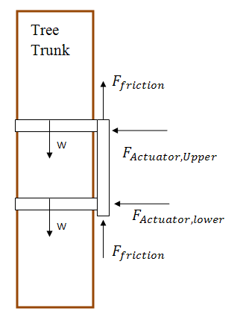

Horizontal Actuator Selection:

$F_{friction}={ μ}_{rubber}* F_{normal}$ (1.4)

$$F_{actuator}=F_{normal} ; { μ}_{rubber}=2.5$$

$${ F}_{friction}= { μ}_{rubber}* F_{actuator}= W_{total}$$

$$W_{total }=W_{actuators} W_{frame}+ W_{cutter}= 24lbf+ 51.9 lbf+50lbf=125.9 lbf$$

$$F_{actuator}= \frac{W_{total}}{{ μ}_{rubber}}=\frac{125.9 lbf}{2.5}$$

$$F_{actuator}= 50.36 lbf$$

The main idea shown is to make the force of the robot’s weight equal to the force of friction holding the robot up. The governing equations to do this are

$$F_{friction}=μ_{rubber}*F_{Actuator}$$

and

$$F_{friction}= F_{gravity}$$

With the weight of the climber being 125.9 lbs and a coefficient of friction of 2.5, we can solve for the force required the actuators, both upper and lower, in order to keep the robot on the palm tree. This is approximately **50.36** pound-force.

Vertical Actuator Selection:

$ΣF_{y}=0$ (1.5)

$$-W_{lower actuator}-W_{upper actuator}- W_{cutter}- W_{frame}+ F_{actuator}=0$$

$$F_{actuator}= W_{horizontal actuators}+W_{vertical actuators}+ W_{cutter}+ W_{frame}$$

$$F_{actuator}=10 lbf+14 lbf+50 lbf+51.9$$

$$F_{actuator}=125.9 lbf$$

This shows that the force required in the Y-axis by both vertical actuators is **125.9** pound-force. This will ensure that the robot will stay on the palm tree.

**#2B: Calculate Required Power**

Next we need to calculate the power.

$$F=125.9 lbf=560 N$$

$P_{required}=F×v=560 N*2.5\frac{in}{sec}$ (1.6)

$$P_{required}=35.56 watts$$

$$12 sec=0.0033 hrs$$

$$35.56 w ×0.0033 hrs=0.117348 watt*hours$$

$P_{Total}=\sum_{0}^{t}{\frac{Δw}{Δt}}=\frac{\left(4\right)\left(50.36 lbf ×6 in\right)+\left(125.9 lbf ×30 in\right)+(85.95 lbf ×30 in)}{\left(4\right)\left(2 sec\right)+\left(12 sec\right)+(11.3 sec)}$ (1.7)

$$P_{Total}=241.67 watts$$

**#2C: Speed Calculation**

After calculating the power, we must calculate the speed at which the robot will be able to climb the tree.

$velocity= \frac{distance}{time}$ (1.8)

In order for it to be calculated the total time in a cycle has to be evaluated by the Climbing Routing:

1. Secure lower actuator to the palm tree:
$$t= \frac{L_{stroke}}{v_{actuator}}= \frac{6 in}{3 \frac{in}{sec}}=2 sec$$

2. Secure lower actuator to the palm tree:

$t= \frac{L_{stroke}}{v_{actuator}}= \frac{30 in}{2.5 \frac{in}{sec}}=12 sec$

1. Secure lower actuator to the palm tree:
$$t= \frac{L_{stroke}}{v_{actuator}}= \frac{6 in}{3 \frac{in}{sec}}=2 sec$$

2. Secure lower actuator to the palm tree:
$$t= \frac{L_{stroke}}{v_{actuator}}= \frac{6 in}{3 \frac{in}{sec}}=2 sec$$

3. Secure lower actuator to the palm tree:
$$t= \frac{L_{stroke}}{v_{actuator}}= \frac{30 in}{2.65 \frac{in}{sec}}=11.3 sec$$

4. Secure lower actuator to the palm tree:
$$t= \frac{L_{stroke}}{v_{actuator}}= \frac{6 in}{3 \frac{in}{sec}}=2 sec$$

5. Retract upper actuator:

$$t= \frac{L_{stroke}}{v_{actuator}}= \frac{6 in}{3 \frac{in}{sec}}=2 sec$$

The time required for 30” climbing cycle = 33.3 seconds.

$$\# Cycles required for 45 ft palm tree= \frac{45 ft* ( \frac{12in}{1 ft})}{30in}=18 cycles$$

$$T_{Required to Climb }=\# Cycles*Climbing cycle time=18 cycles ×33.3 sec=9.99 min$$

$v_{Robot}= \frac{45 ft}{9.99 min}=4.5 \frac{ft}{min}=0.075\frac{ft}{sec}$ (1.9)

**#3: Testing chosen material strength**

Now that weight and loads have been calculated, we need to go back and test the material that was originally selected. Aluminum 6061-T6 is a strong metal with yield strength of 42,000 psi. The weight of the robot is distributed among two actuators. As a result, the load applied to the cross-section of the beam is 62.95 lbs. The stress equation for simple tension is

$σ= \frac{F}{A}$ (1.10)

Sigma represents the engineering stress, F represents the force, and A represents the area that the force is being applied to. The dimensions are 2.0" x 2.0" x 0.125" and the cross-sectional area of the square tubing is 0.5 ${in}^{2}$.

$$σ= \frac{62.95 lbf}{0.5 {in}^{2}} =125.9 psi$$

2.0”

0.125”

2.0”

These results reveal that the metal will not yield under the stresses applied. Next, we must test the deflection of the supporting structure under the applied load. The governing equation for the deflection of the beam is

$δ=\frac{F*L}{A*E}=\frac{125.9lbf*22in}{0.5{in}^{2}*62400\frac{lbf}{{in}^{2}}}=0.088in$ (1.11)

Also, E represents Young’s modulus of the material. Using the entire length of the circular track to represent the beam length, we calculated the deflection to be 0.088 inches.

**#6: Generate a Rough Cost Estimate**

Based on our previous calculations, we were able to figure out material costs as well as

potential companies that we could purchase our materials from. Figure 7 provides a summary on

our calculated information.

**Figure 7: Summary of Concept #1 Design:**

|  |  |  |  |  |
| --- | --- | --- | --- | --- |
| **Material** | **Weight (lbs)** | **Quantity (unit)** | **Cost ($)** | **Total Cost ($)** |
| AL6061 | 51.9 | 36 ft (Ordered extra) | 5.59 per ft | 201.30 |
| Supports | * | 4 | * | * |
| Cutter | 50 | 1 | * | * |
| H Actuator | 5 | 2 | 159.00 | 318.00 |
| V Actuator | 7 | 2 | 169.00 | 338.00 |
| **Total** | 125.9 |  | | 857.30 |

**Total Cost:** $201.3 + $318.00 + $338.00 = $857.30

**Maximum Instantaneous Power Requirement for Al6061: $35.56 watts$**

**Maximum Applied Stress on to Al6061 frame:** 125.9 psi

**Speed: $0.075\frac{ft}{sec}$**

## Concept 2: Rolling Thunder

The Rolling Thunder design was one of the top ideas that became one of our potential design concepts. Shown in Figure 8a, the overall design relies on the orange wheels pressed into the tree by the red springs in order to secure itself to the trunk of the tree. Then, after it is secure, it uses the black motors attached to the wheels to drive the wheels up the tree. The frame and legs are light blue and are made out of boxed aluminum. The main structure is rolled into a ¾ circle leaving a gap wide enough to allow the trunk of the tree to be inserted into the center. The outer rim of the circular track is to be used for the guiding rail of the manipulator arm. Also, we created a Pro-E simulation in order to gain a better understanding as to how the Rolling Thunder design will operate.

**Figure 8a: Pro-E for Rolling Thunder**

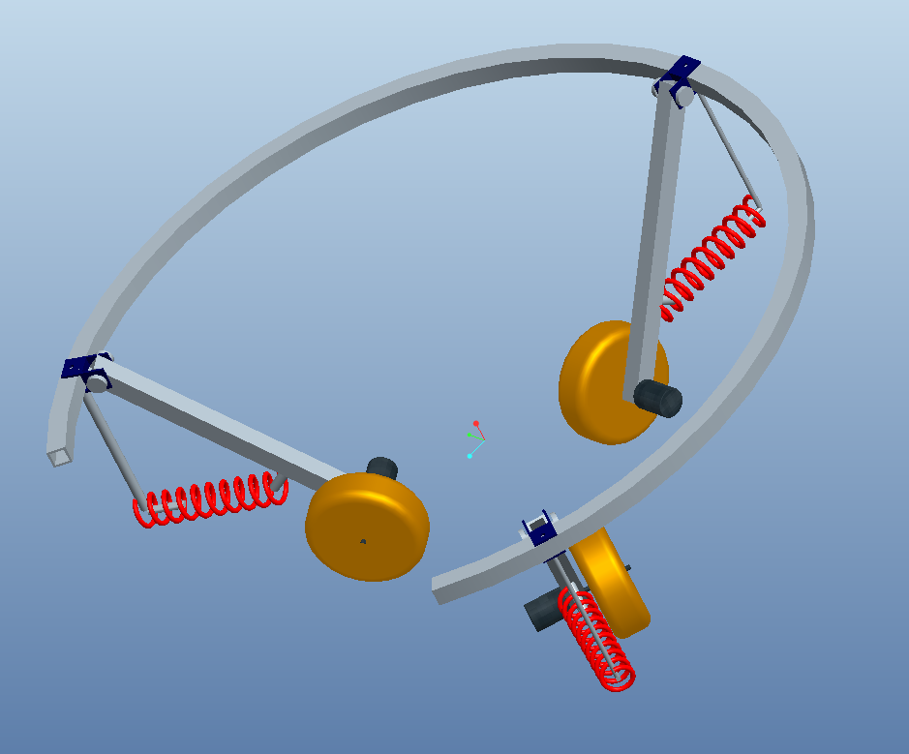

Figure 8b shows the rolling thunder design from a top view. The tree trunk would be located in the center of the three orange wheels and secured by the red springs.

**Figure 8b: Top View**

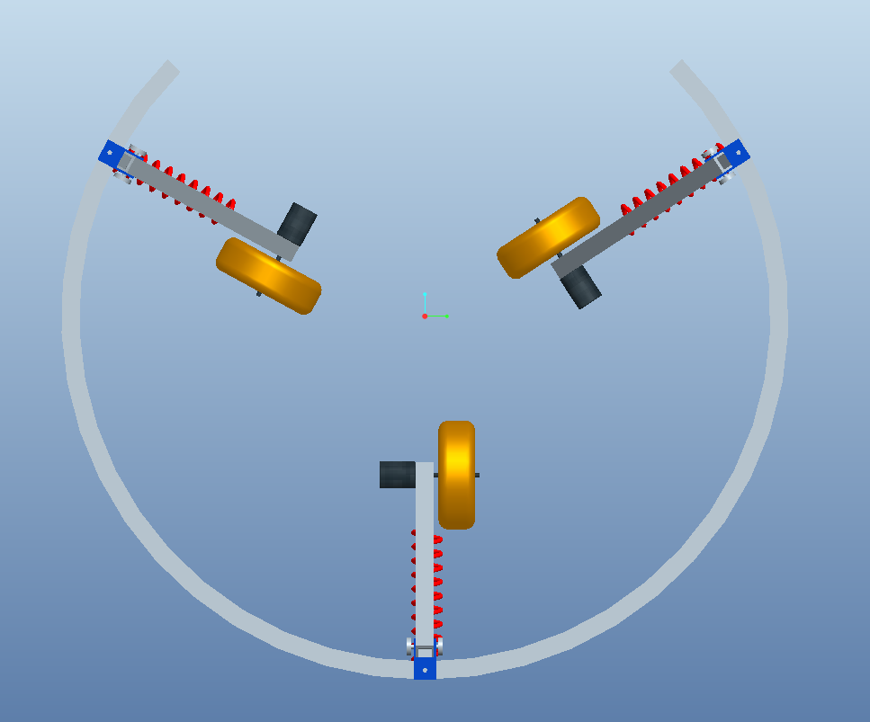

The Figure 8c portrays a side view of the Rolling Thunder design from the perspective of the opening in the main track. The black motors, orange wheels, red springs, and light blue structure are all clearly visible.

**Figure 8c: Side View**

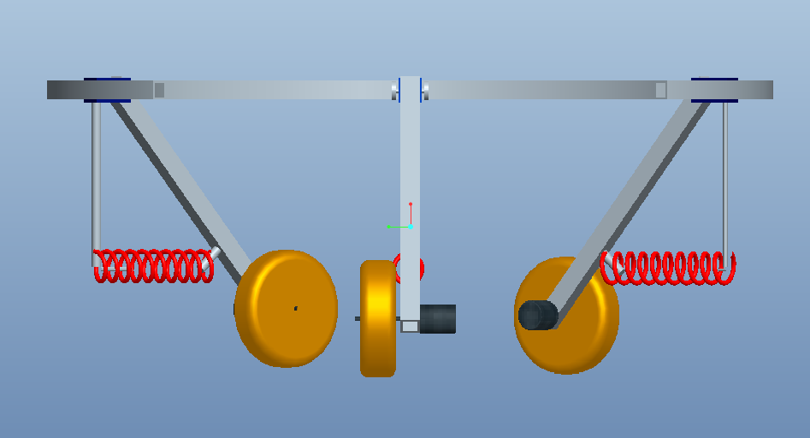

**Results of Analysis of Design**

**#1: Testing Geometry and Calculating Weight**

Geometric Calculations:

The first step in our calculations was to figure out the average diameter of the palm. We found this to be approximately 14 inches as previously stated in the define phase. After taking this into consideration, we decided that on either side of the palm, there should be at least 12 inches of free space for the actual machine. As a result, the radius of the wheeled robot frame would be 19 inches and the total diameter would be 38 inches. The robot will encompass a total of 270 degrees of the palm. As a result, this concept design must take into account an opening gap of 26.8 inches deduced via Pythagorean Theorem.

$C=\sqrt{A^{2}+B^{2} }$ (2.1)

Next, we solved for the length of the legs required. We utilized SOH CAH TOA, angle at 45 degrees, with a length of 12 inches. The 12 inches accounted for the space between the actual palm and the machine on either side. We obtained that the required length of each leg is 16.97 inches.

$H=\frac{A}{cosϴ}$ (2.2)

Weight Calculations:

We chose the opposite side of the open gap as the center with a wheel at 120 degrees in either direction. Also, we took into account the 135 degrees of track on either side from the chosen center. With this, we were able to calculate how much AL6061 was needed so that we could build our robot. The robot encompasses 270 degrees or ¾ of the palm tree. Need material lengths are summarized in Figure 9a.

**Figure 9a: Material Lengths**

|  |  |
| --- | --- |
| **Raw Material Lengths**  **(Al 6061)** | **Length (inches)** |
| Circle Track | 89.54 |
| Struts (x3) | 24 |
| Legs (x3) | 48 |
| Total needed: | 161.5 |

Next, we found the density of AL 6061 to be 0.098 $\frac{lb}{{in}^{3}}$ from a metal surplus site and then calculated the area. We did this by looking at the AL profile 1”x1”x0.125” and calculated the area to be 0.44 ${in}^{2}$. From this information, we found the weights for our individual materials as well as the total weight shown in Figure 9b. The total weight of the concept 2 design was 57 lbs.

**Figure 9b: Material Weights**

|  |  |
| --- | --- |
| **Material** | **Weight (lbs)** |
| Frame | 7 |
| Wheels | 18 |
| Motors | 2 |
| Pay Load | 25 |
| Springs | 5 |
| Total | 57 |

**#2A: Calculating force to keep the robot on the tree**

In order to calculate the force, the first step was to create the free body diagram shown in

Figure 9c. This allows us to analyze the forces acting on the body.

**Figure 9c: Free Body Diagram of Rolling Thunder Design**

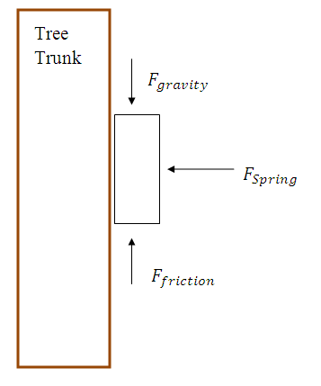

The main objective here is to make the force of the robot’s weight equal to the force of friction holding the robot up. The governing equations to do this are

$F_{friction}=μ*F_{spring}$ (2.3)

and

$F_{friction}≥ F_{gravity}$ (2.4)

The symbol µ is the coefficient of friction. Equation 2.4 must be true for the wheels which means that the robot will stay on the tree. Knowing the weight of the climber to be approximately 60 lbs as well as the coefficient of friction for rubber on a solid to be 2.5, we can use this information to solve for the spring force. Calculations show that each spring needs to put at least **24lbs of force** onto the wheels in order to secure the robot to the tree.

**#2B & 2C: Calculating required torque, power and speed**

Next, we need to calculate both torque and power. Torque is governed by

$T=F*r$ (2.5)

with T being Torque, F being force and r being radius. The Figure_ below illustrates how the forces will interact with one another. We found that we need about **15 ft-lbs** of force in order to hold the wheels on the tree and keep the machine from rolling backwards. Figure 10a provides a visual of the forces required in order to calculate torque.

**Figure 10a: Free Body Diagram Showing Torque Interaction**

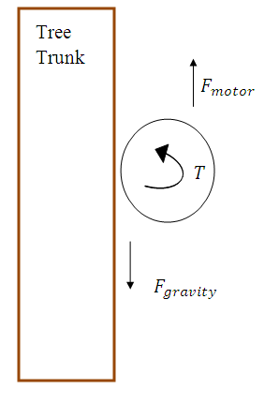

To solve for power the governing equation is

$P=T*w$ (2.6) with P representing power and w representing the angular velocity. By setting torque to be 15 lb-ft over the original stall torque and making the robot roll up the tree at a speed of **1 ft/s**, we were able to calculate that the robot requires about **0.1 hp of power**.

**#3: Testing chosen material strength**

Now that we have calculated weight and the respective loads, we must go back and test our originally selected material, Aluminum 6061. This is a relatively strong metal having a yield strength of 40,000 psi. In our concept design, the wheel legs must support the most force because they need to be strong enough to act against gravity. Utilizing this information, the weight of 60lbs is divided by the three legs so each leg receives 20 lbs of force on it. The stress equation for simple tension is

$σ= \frac{F}{A}$ (2.7)

with sigma representing the engineering stress, F representing the force, and A representing the area that the force is being applied to. With the boxed 1"x1"x0.125" Aluminum, the area is 0.44 in2 and has a resulting stress of **45.45 psi** which is much smaller than the 40,000 psi allotted.

These results reveal that the metal will not yield under the stresses applied. Next, the deflection of the supporting structure under the applied load can be found through the equation:

$δ=\frac{F*L}{A*E}$ (2.8)

The E represents Young’s modulus of the material. Using the entire length of the circular track to represent the beam length, we calculated a deflection of 0.3 inches.

**#4: Rough Cost Estimate**

After all calculations were completed, we were able to figure out the specifications

and cost associated with each part. A breakdown of the needed material, weights,

quantity, as well as total costs are depicted in Figure 11**.**

**Figure 11: Summary of Concept #2 Design:**

|  |  |  |  |  |
| --- | --- | --- | --- | --- |
| **Material** | **Weight (lbs)** | **Quantity (unit)** | **Cost ($)** | **Total Cost ($)** |
| AL6061 | * | 20 ft | 2.57 per ft | 51.40 |
| Wheels | 18 | 3 | 13.00 | 39.00 |
| Springs | 5 | 3 | 5.75 | 17.25 |
| Motors | 2 | 3 | 84.00 | 252.00 |
| Generator (1000 watt) | * | 1 | 150.00 | 150.00 |

**Total Cost:** $51.40+$39.00 +$ 17.25+$252.00+$150.00= $509.65

**Power Requirement for Al6061:** 0.1 hp

**Stress Factor of Al6061:** 45.45 psi

**Force to Hold Wheels on Palm:** 15 ft-lbs

**Speed:** 1ft/sec

# Evaluation of Results

After utilizing all of the selection tools, we came to the conclusion that the King Climber was the better concept overall. We took into account many different factors to reach this decision. Although one of the designs may produce better results in one selection tool, does not mean that it is the optimal decision. We have to take into account each and every resource at our disposal.

We used the House of Quality from our define phase to set our desired criteria for the robot. The define phase determined the parameters that we chose to measure and evaluate for the actual measure phase. Basically, our robot needed to be inexpensive, lightweight, require minimal force, as well as be efficient when it comes to climbing up and down the palm tree.

The Venn Diagram helped us determine the similarities and differences between the two

concepts. This is extremely beneficial because we can decide which factors are more important

than others. The reason for this is because if two concepts have similarities then the similarities

are not going to be the deciding factors. The deciding factors come from the differences in the

concepts.

Another beneficial tool was the Traditional Selection Matrix. This matrix is more result based. This means that the matrix is taking into consideration the quantitative values measured by our team. Basically, the concept with the lower score is the better choice. The Rolling Thunder had the lower score of 18.5, compared to 24.46 for the King Climber. These values alone cannot provide us with the optimal concept design because they are so close. Along with the similarity in numbers, this selection matrix does not include some of the metrics due to the fact that the objective is to choose the lower values.

The King Climber scored the highest value on the Pugh Matrix, which took into account all of the desired criteria. The goal of Pugh Matrix is to score the highest value. The King Climber scored a value of 9 on this selection tool, which is much greater than that of the Rolling Thunder. The Rolling Thunder, consequently, scored a value of -9. When we compare these two values, we get a better look at how the two concepts stack up against each other. The only downfall in the King Climber is that this design climbs at a slower pace than that of the Rolling Thunder. We believe this to be directly correlated to the productivity of our mechanism. As a result, the faster the apparatus can move, the more fruit the apparatus can harvest.

In the end, the King Climber concept design appears to be the more promising of the two potential concept designs. Due to our budget of $2000, as well as, our time constraint, we are limited in that we must lean towards a more simplistic, realistic, and achievable design. Both designs are well under our budget constraint; however, King Climber is the better choice because of various factors. Our decision is justified based on the techniques we implemented to evaluate and rank our parameters.

# Conclusion

The next step of the design process is to successfully order the parts necessary to assemble the King Climber robot. We are able to order parts because of the engineering analysis we conducted on the King Climber design. We have selected to purchase these actuators from Firgelli Automations. They provided the most suitable, inexpensive actuators for our design. Our electric generator will be purchased from Sunpentown International Inc. Based on the coefficient of friction, we have chosen an aluminum frame purchased from Grainger. We chose to use Grainger because Florida State University has a strong relationship with them concerning ordering parts, as well as, the fact that it is located in Tallahassee. Finally, we will purchase the the microcontroller from WYTEC, a company suggested to us by Dr. Chuy. Once all of the materials arrive, our next step will be to assemble the King Climber robot. Because of this measure phase, we were able to choose a design concept as well as provide justifications as to why we chose that design. Also, through calculations, we were able to select the parts that would be crucial to our design in order to aid in fabrication and allow an easy assembly.

# 

# Appendix:

1. Fishbone Diagram

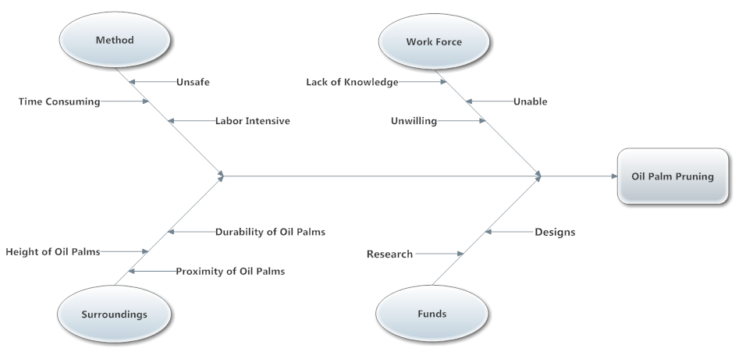

1. House of Quality



1. Voice of Customer Tree

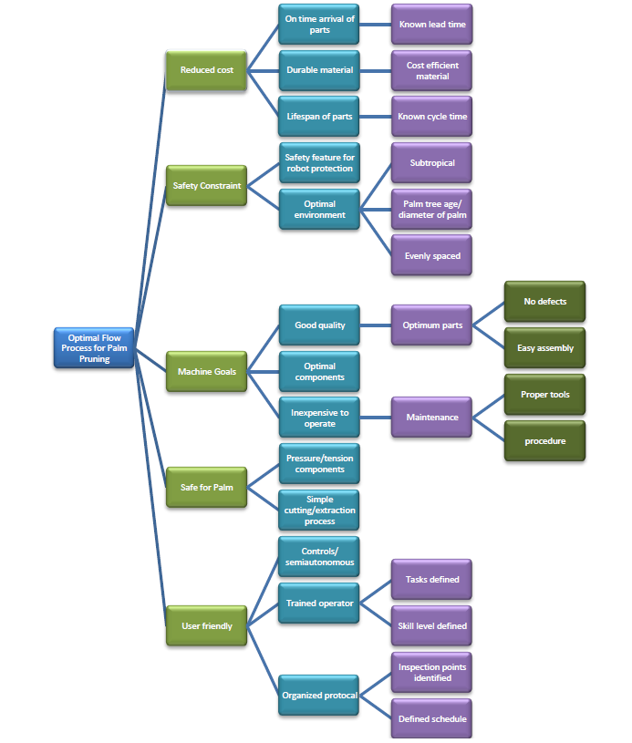

1. Pro-E Screen Shot Picture Simulations from Beginning to End
   1. Robot Extended Compact

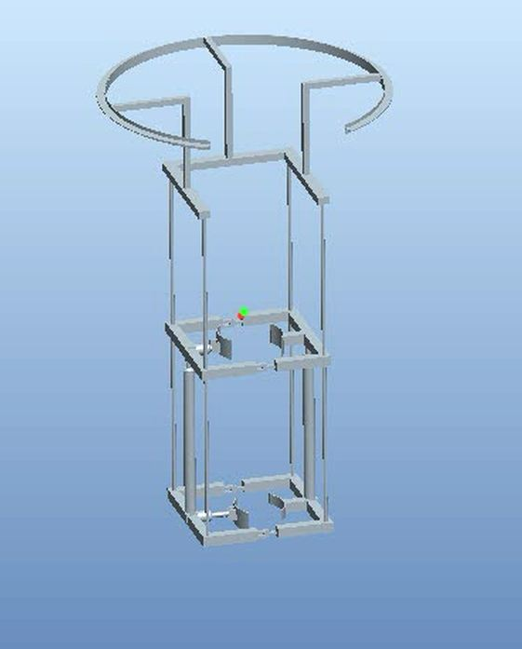

* 1. Compact Top Clamp

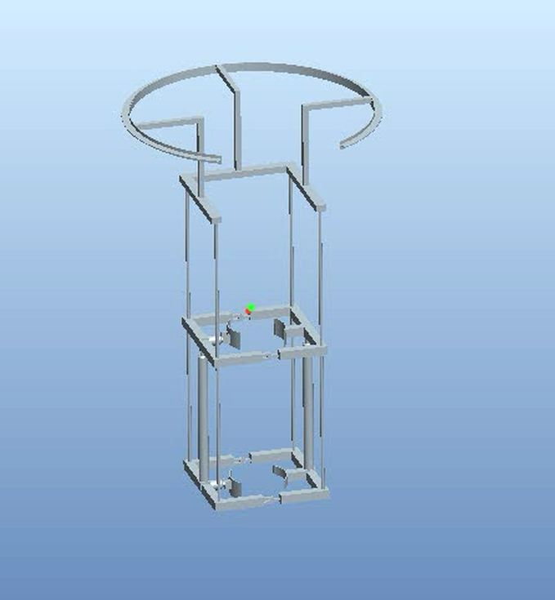

* 1. Compact

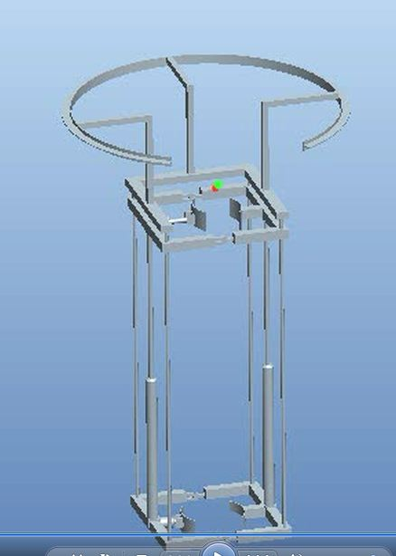

* 1. Extended Top Clamped



* 1. Extended Top Opened

